FSD for Tia & Noordin Mobile App

PHASE 1 - SPA

8/2/2015

ABEO INTERNATIONAL PTE LTD

Yinhui

VERSION 9.0

Table of Contents

Objective of Mobile App 2

Expected Authorized Scope of Users of Mobile App 2

Login Screen 3

Dashboard 4

Dashboard-Side Panel 7

WALK-IN 9

Individual 10

Corporate 13

Property 14

List of Property 15

List of Cases 16

Add Case – Step 1 17

Add Case Step 2 18

Add Case – Step 2, Open case exists for property 19

Add Case – Step 3 20

Add Case: Step 4 21

Case Enquiry – Details 22

Case Enquiry – Purchaser 23

Case Enquiry – Vendor 24

Case Enquiry – Property 25

Case Enquiry – Loan (Principle) 26

Case Enquiry – Loan (Subsidiary) 27

Case Enquiry – Process 28

Acknowledgement 31

## Objective of Mobile App

        The main objectives of the mobile apps are as follows:

1. For the IC to operate completely on the tablets and NOT access SAP
2. To mask the entire ERPs from rivals with Mobile apps as front
3. Easy of usage
4. Impress clients with the efficiency of handling cases.
5. exercise control over IC
6. provide easy access for managers and lawyers to oversee the entire operation

## Expected Authorized Scope of Users of Mobile App

* Lawyers and managers see all of the case details and listing
* IC see partial and limited to their own cases handled

## 

## Login Screen

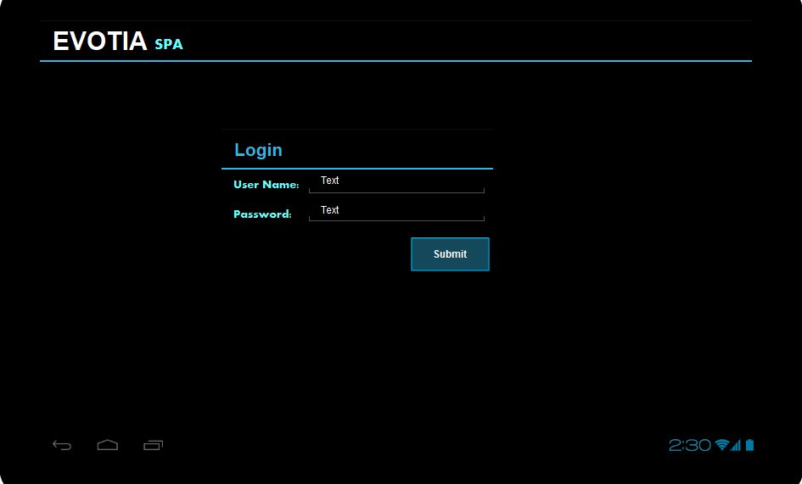

1. Enter User Name and Password. Click Submit to Login.
2. After login, direct to Dashboard.

Setup & Process in the SAP

* 7 Roles (hem6.roleid) to be created: SPA, Loan, Transfer, Discharge, Litigation, Tenancy, Will_Trust.
* There will be 7 mobile apps, one for each role.   
    
  An employee must be a member of the role to access the corresponding mobile app. For example, Christine is a member of SPA but not Litigation. She will have access to SPA mobile app and no access to Litigation app.
* Each Role to have 4 subroles(hem6.u_subrole): Customer Service (CS), In-Charge (IC), manager (MG), partner (PT) and Legal Assistant (LA)
* All mobile app users will be created as an employee in the employee master data.
* Each employee will be a member of at least one role with a single subrole in each role.

Verification

* Every mobile app will have a role name.
* Verify role name and subrole, user name and password with HR

# Dashboard

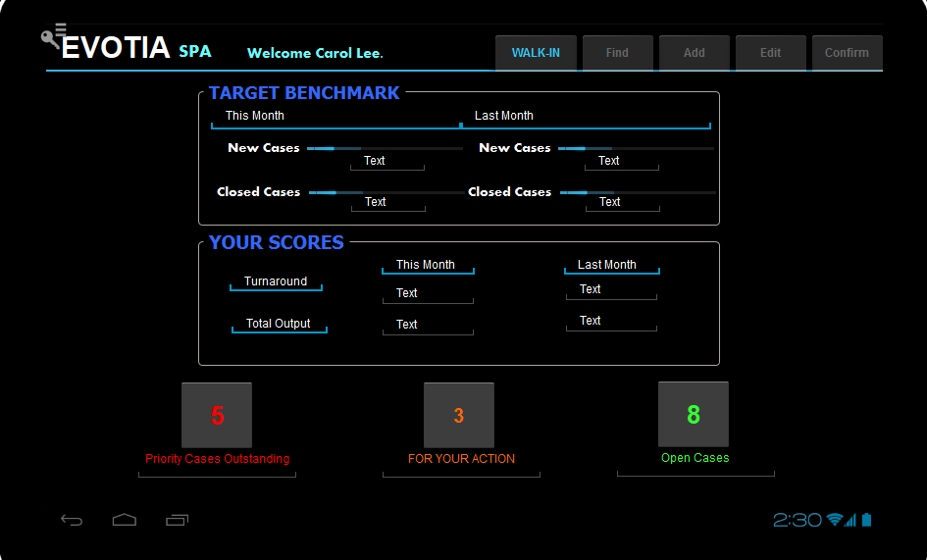

Objective:

* KPI this month and last month
* Short cut buttons to zoom into each category

Details:

Target Benchmark

|  |  |
| --- | --- |
| This Month | Last Month |
| New cases  100% | New cases  100% |
| Closed cases  70% | Closed cases  70% |

100% is based on New Cases Benchmark defined at Employee Master. Each employee has a different benchmark.

Employee Master in SAP is maintained in SAP to keep information specific to employee.

This will not be shown in Mobile Apps.

100% is based on Closed Cases Benchmark defined at Employee Master. Each employee has a different benchmark.

Progress Bar is indicative for current month and last month data base on this benchmark. Progress bar does not have percentage. Percentage will be shown as supporting text below the progress bar.

**Your Scores**

|  |  |  |
| --- | --- | --- |
|  | This Month | Last Month |
| **TURNAROUND** | 0.89 | 1.11 |
| **Total Output** | 18 | 21 |

Every case type (BP group) will have a benchmark turnaround days.

For example, sub-sales cases have benchmark turnaround days of 90days.

If case A takes 80days, it will get a score of 80/90=0.89.

If case A takes 100days, it will get a score of 100/90=1.11.

Score 1: Turnaround = sum of all scoring / total number of cases (this month to-date and last month figures, not cumulative).  
It measures how the cases are closed.

Score 2: Total Output Score = Number of cases closed  
It measures how many cases are closed.

Tia & Noordin requires every employee to have a different benchmark. Hence, Tia & Noordin’s management will maintain the benchmark for each employee and category in the SAP Human Resource.

CLOSED

OPEN

ACTION

PRIORITY

CR: We agreed to remove “Closed” short-cut key.

* Find, Add, Edit and Confirm buttons are disabled.
* Walk-in button enabled to direct to service Walk-in Customer.
* 4 quick buttons to zoom into relevant, open, outstanding cases.
* User clicks “Priority Cases outstanding”.
* Program directs to “List of Cases” with input parameters:
  + Case type: “Priority”
  + Case status: “Open”
  + Usercode: User Code
  + Date From: ““
  + Date To: “”
* List of Cases will select all high priority, open cases where the user code exists in one of the fields: Manager, LA, In-charge, reception and partner.
* User clicks “Open Cases”.
* Program directs to “List of Cases” with input parameters:
  + Case type: “”
  + Case status: “Open”
  + Usercode: User Code
  + Date From: ““
  + Date To: “”
* List of Cases will select all open cases where the user code exists in one of the fields: Manager, LA, In-charge, reception and partner.
* User clicks “Closed Cases by IC month”.
* Program directs to “List of Cases” with input parameters:
  + Case type: “”
  + Case status: “Closed”
  + Usercode: User Code
  + Date From: date 1 month ago from current date
  + Date To: current date
* List of Cases will select all cases closed within the date from and date to range and the user code exists in one of the fields: Manager, LA, In-charge, reception and partner.
* User clicks “For Your Action”.
* Program directs to “List of Cases” with input parameters:
  + Case type: “Pend”
  + Case status: “Open”
  + Usercode: User Code
  + Date From: “”
  + Date To: “”
* List of Cases will select open cases pending this user.

Setup & Process in the SAP

* Every case is a OCRD record.
* Each case has a status
* Each employee is given a benchmark for the turnaround days for closed cases each month (hem6.u_BMTurnaround)
* Each employee is given a benchmark for number of closed cases each month (hem6.U_BMClosedCases) and the number of open cases (hem6.U_BMNewCases) each month.

Action in Mobile App

* Progress Bar calculation for new cases this month=((# of cases assigned to user with date opened in this month / user open case benchmark) /2) *330
* Progress Bar calculation for new cases last month=((# of customers assigned to user with date opened in last month / user open case benchmark) /2) *330
* Progress Bar calculation for closed cases this month=((# of customers assigned to user with date closed in this month / user close case benchmark) /2) *330
* Progress Bar calculation for closed cases last month=((# of customers assigned to user with date closed in last month / user close case benchmark) /2) *330

# Dashboard-Side Panel

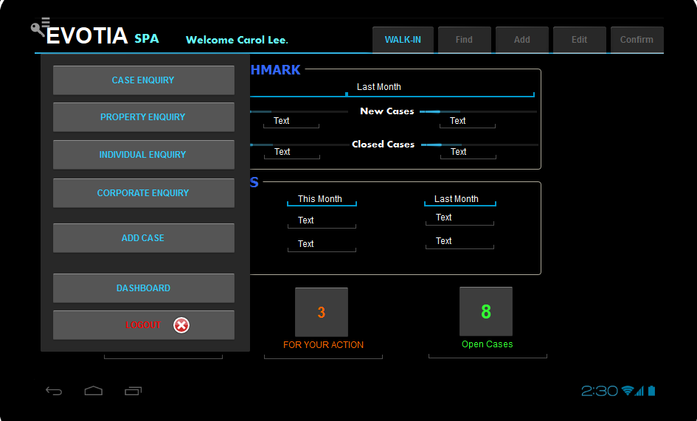

Objective:

* The Control Key on the upper left. Click to open up more function keys.
  + Case Enquiry (Can only be accessed by Managers, LA and Partners. Dim off if user is not one of them.)
    - Selection Criteria are:
      1. File Opened Date From
      2. File Opened Date to
      3. Case File No.
      4. Case Type
      5. 1st Client Name (Partial Name can also be found)
      6. Case Amount from
      7. Case Amount To
  + Property Enquiry
    - Selection Criteria are:
      1. Title Type
      2. Title No
      3. Lot Type
      4. Lot/PTD/PT No.
      5. Formerly known as
      6. Bandar/Pekan/Mukim
      7. Daerah
      8. Negeri
  + Individual Enquiry
    - Selection Criteria are:
      1. Name
      2. Mobile
      3. ID
  + Corporate Enquiry
    - Selection Criteria are:
      1. Company Name
      2. Address
      3. Business Reg No.
  + Add Case   
    Dim off (cannot create case if user is not CS and not IC)
  + Dashboard
  + Logout -CR: change to RED font color and add EXIT ICON

SETUP & PROCESS IN SAP

* Cases can be created by CS or IC.  
  + CS => creator of the case (CS or IC)
  + IC => the IC with the least number of open cases in the role
  + MG => the manager with the least number of open cases in the role
  + LA => the LA with the least number of open cases in the role

# WALK-IN

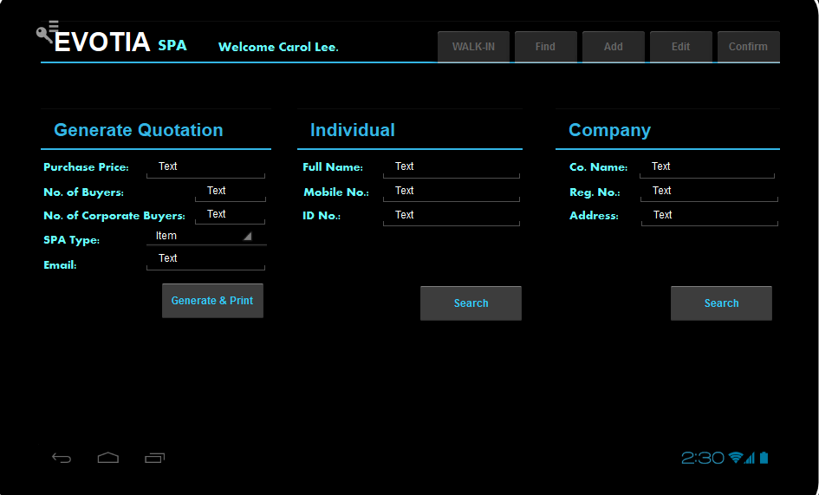

1. User enters purchase price, no. of buyers, no. of corporate buyers and spa type.
2. User clicks “Generate & Print”.
3. Program will Print Preview the Quotation. Quotation in PDF displayed on top of screen.
4. User clicks “Print” to print.
5. User to Save PDF using PDF Addon if required. User can email quotation in PDF to customer.
6. User keys in either 2 of the 3 “Full Name”, “Mobile No.” and “ID No.”.
7. If user key in the name, not necessary full name. Can be partial check.
8. User clicks “Check Individual”.
9. Program directs to “Check Individual” screen.
10. User keys in either 2 of 3 “Co. Name”, “Reg. No” and “Address”.
11. If user key in the name, not necessary full name. Can be partial check.
12. User clicks “Check Company”.
13. Program directs to “Check Company” screen.

# Individual

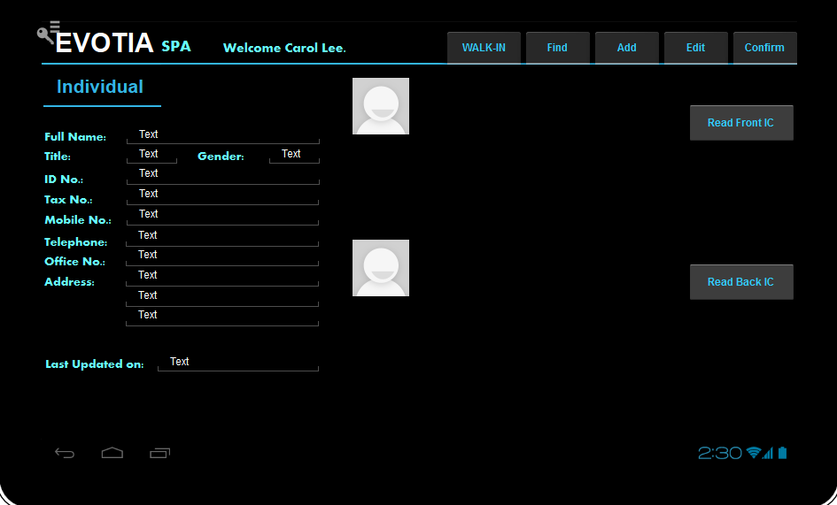

1. If an exact match is found, display individual record.
2. Click Edit to update the existing record.
3. User can re-scan IC. The front and back of IC can be shown.
4. Click Confirm to Save.
5. If no change the Confirm button should be always dimmed off, no update required.

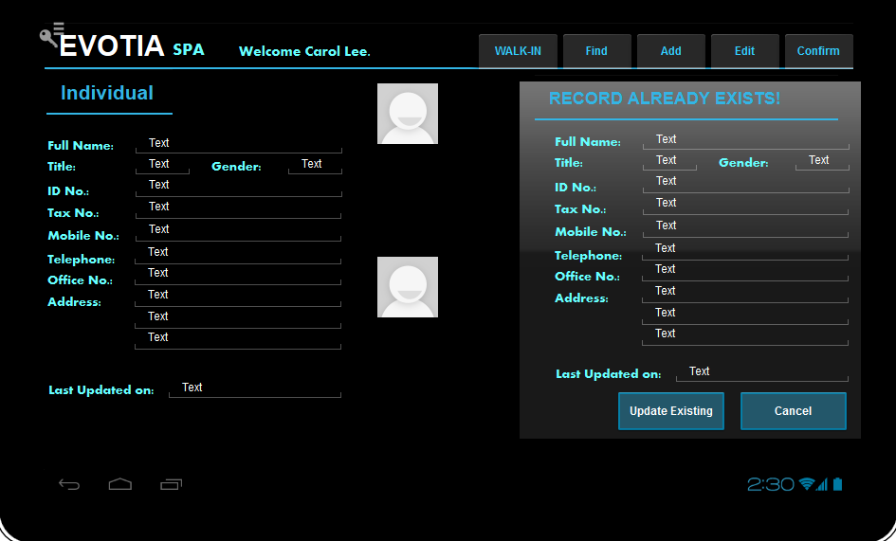

1. If no exact match found, system returns blank.
2. Click Add to create a new record.
3. Scan IC and entering the details.
4. Click Confirm to Save.
5. If IC duplicated, warn duplicated IC and pull out existing record.
6. Click Cancel or Update Existing Record.
7. Click Find to change to find. Choose from drop down list either Individual or Cases related to this Individual.

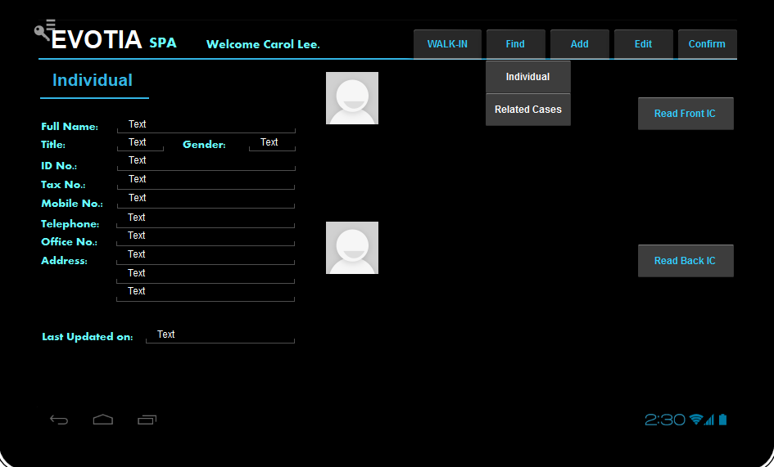

1. If User Click Individual,
   1. Change all fields to Non-editable, except Full Name, Mobile and ID No.
   2. User enters 2 out of 3 fields. Click Confirm.
   3. Retrieve record of another Individual.

If User Click Related Cases,

1. Pull out list of cases related to this Individual found.

# Corporate

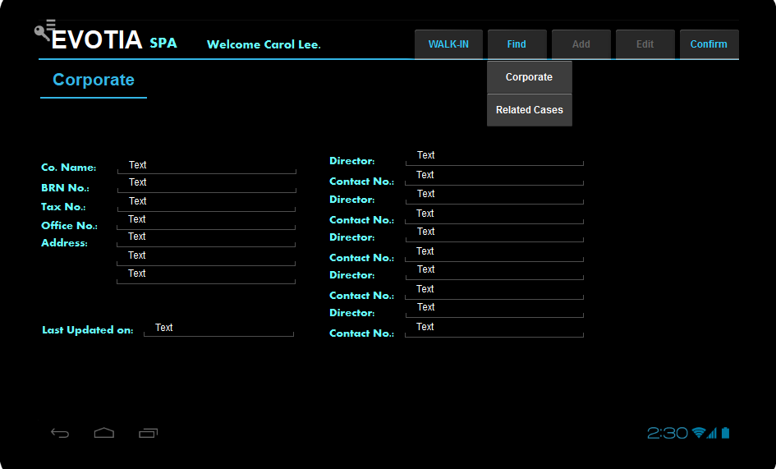

1. If an exact match is found, display individual record.
2. Click Find to change to find mode.
3. User clicks Corporate.
4. All fields are dimmed off. Only Company Name, Office No and Address are editable.
5. User enters 2 out of 3 fields. Click Confirm.
6. Retrieve record.
7. Add and Edit actions are not allowed on Corporate Records in mobile app.
8. Click Find to change to find mode.
9. User clicks Related Cases.
10. System pulls out a List of Cases.
11. User chooses one of the Cases.

# Property

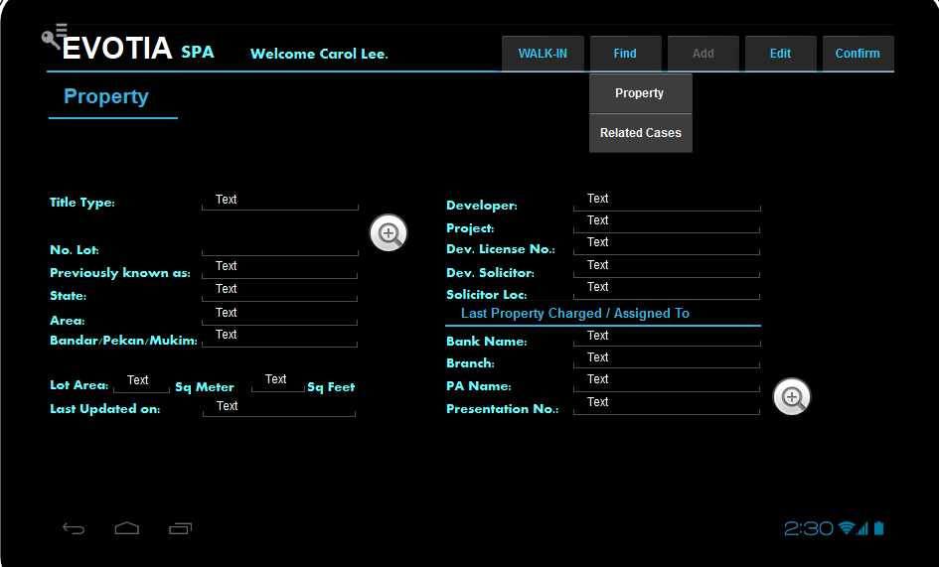

1. User clicks Property Enquiry in Control Key.
2. User clicks Find.
3. User clicks Property.
4. User enters some information and click Confirm.
5. If no information entered/edited/updated, the Confirm button should be dimmed off.
6. Show List of Property.
7. User chooses 1 property.
8. User can click the Zoom button to show Scan file Presentation Number and the Last Land Search.
9. User cannot add a property without creating new case.
10. User clicks Property Enquiry in Control Key.
11. User clicks Find.
12. User clicks Related Cases.
13. System pulls out List of Cases related to this property.
14. User chooses a case from the list.

# List of Property

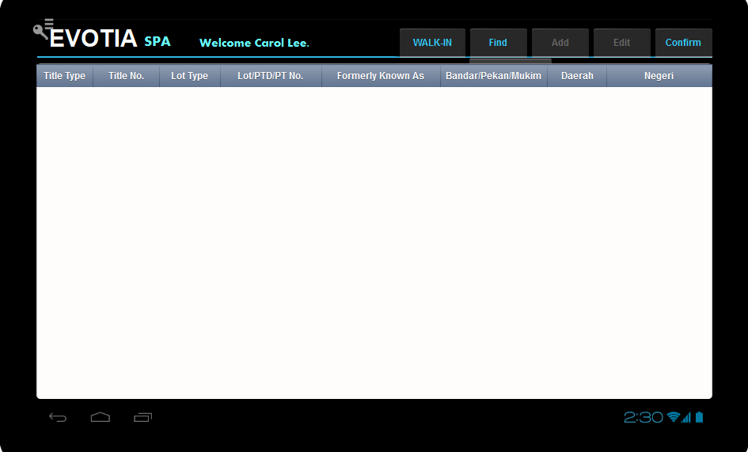

1. User clicks to choose Property.  
   List of property, 8 fields - key title number is "Lot/PTD/PT No."

# List of Cases

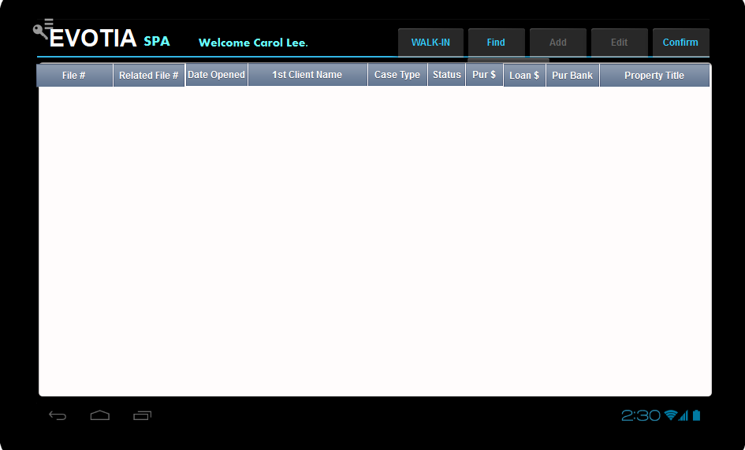

Change the list of cases to the following table.

|  |  |  |  |  |  |  |  |  |  |  |  |  |
| --- | --- | --- | --- | --- | --- | --- | --- | --- | --- | --- | --- | --- |
| CaseFile No. | Related File No. | Branch Code | File Opened Date | IC | Case Type | 1st Client Name | Bank | Lot/PTD/PT No. | Case Amount | User Code | Status | File Closed Date |
|  |  |  |  |  | *5 types |  |  |  |  | *6 user codes | Open/Closed/Cancelled |  |

CR: How to differentiate branch?

YH: it was discussed that branch code will be entered in BP name. JJ/100000929918, which will be reflected in the Case File No. Branch code is appended base on the employee master branch code of the employee the case is created by.

So no need branch code.

CR: SAP user can easily sort cases according to branch without Branch Code, if so, pls ignore this.13 fields to 12 fields.

CR: List of case is pulled from SAP? If so, we need to maintain the table consistent for all type of cases.

Total 13 fields in List of Case, may add more later.

YH: noted. Fields to be added in the next phase with the other modules.

FINAL DECISION TO HAVE 13 FIELDS AS PER HIGHLIGHTED IN RED ABOVE.

1. User click to choose case.

# Add Case – Step 0, Questionnaire

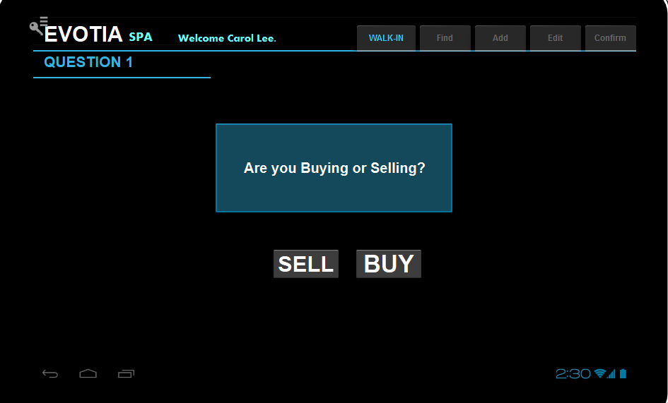

If user click “SELL”:

1. update Vendor “Represented by Firm” as Yes
2. update Vendor “Represented by Lawyer” as Yes
3. proceed to Step 1 of 4.

If user click “BUY”:

1. Proceed to Question 2.

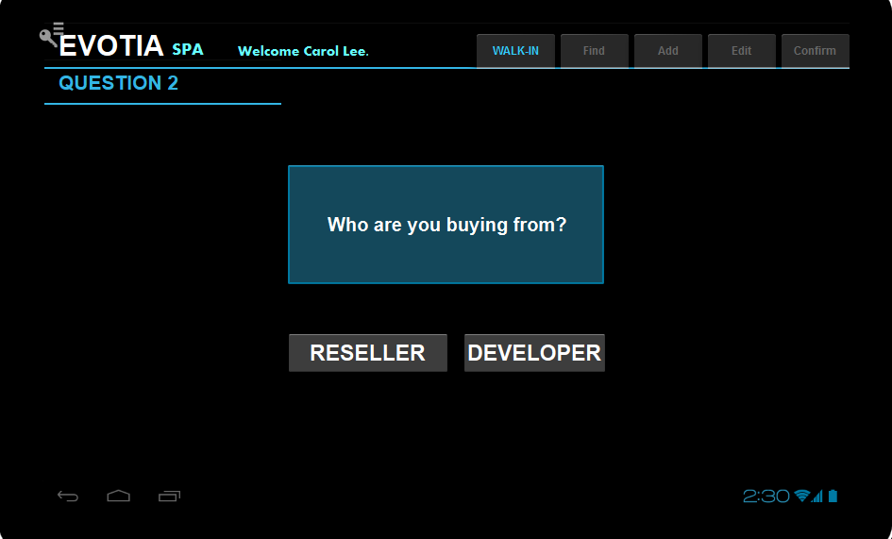

If user click “RESELLER”:

1. Update Case_PropertySource as a “RESALE”
2. Proceed to Add Case Step 1.

If user click “DEVELOPER”:

1. Update Case_PropertySource as a “DEVELOPMENT”
2. Proceed to next question.

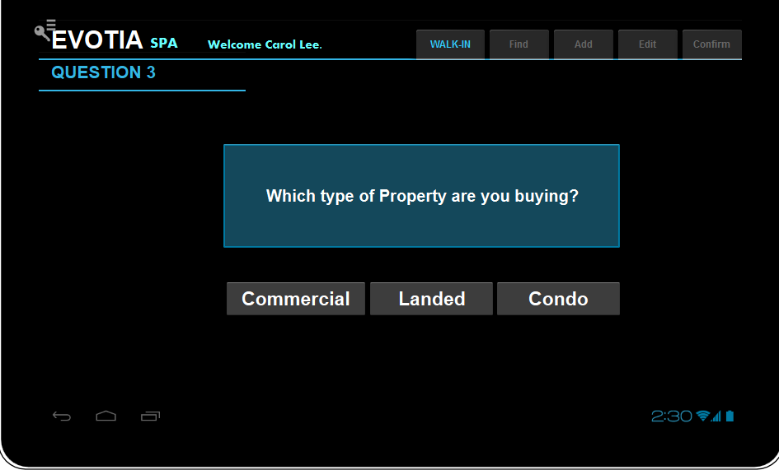

If User Click Commercial,

1. Update Case_PropertyType = “COMMERCIAL”.
2. Proceed to Add Case Step 1 of 4.

If User Click Landed,

1. Update Case_PropertyType = “LANDED”.
2. Proceed to next question

If User Click Condo,

1. Update Case_PropertyType = “CONDO”
2. Proceed to next question

# Add Case – Step 1

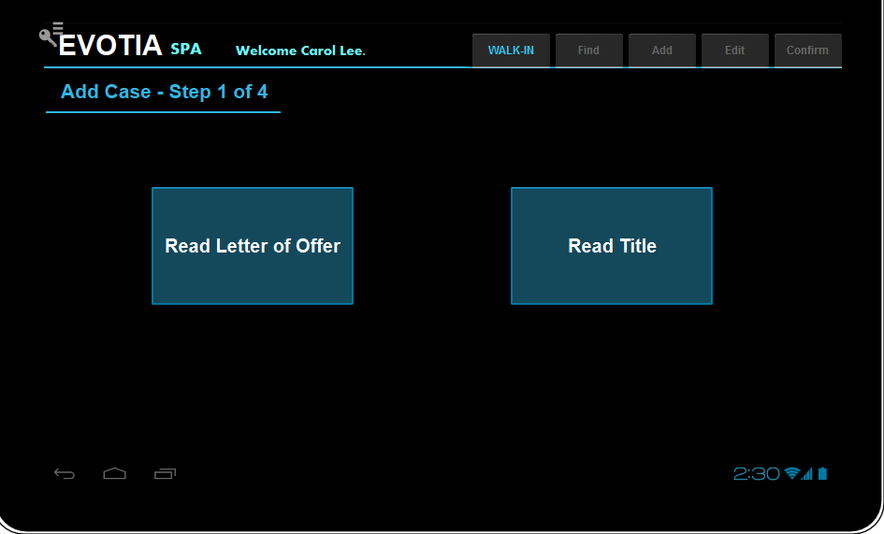

1. User clicks Read Letter of Offer OR Read Title.

# Add Case Step 2

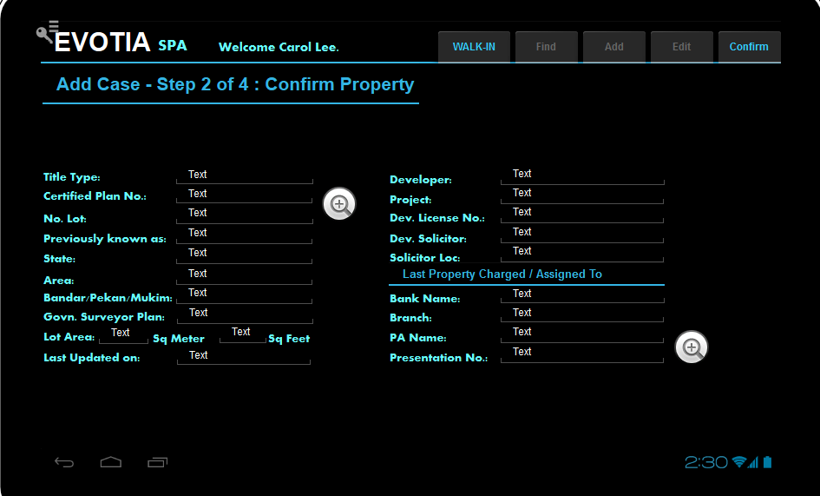

1. Remove Certified Plan No and Govn. Surveyor Plan from the field lists.
2. User verify scanned data.
3. User modify if scan quality is bad.
4. User clicks Confirm to save.

# Add Case – Step 2, Open case exists for property

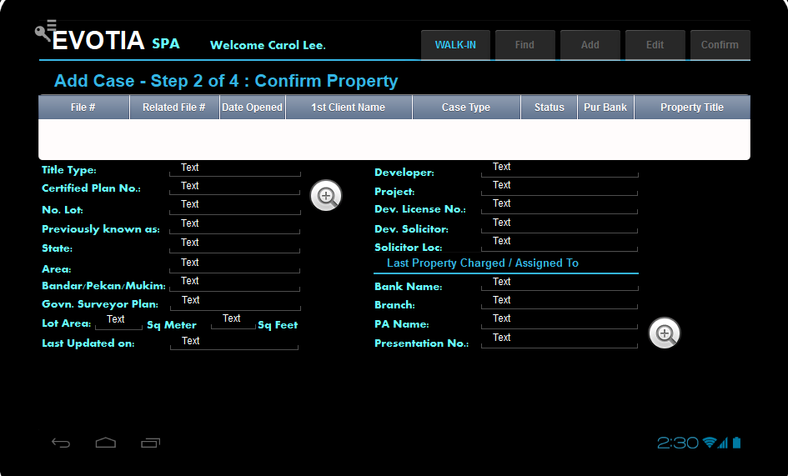

1. Remove Certified Plan No and Govn. Surveyor Plan from the field lists.
2. Confirm button is dimmed off.
3. Open case for same property will be extracted and shown.
4. User click to jump to case enquiry case for the selected case.

# Add Case – Step 3

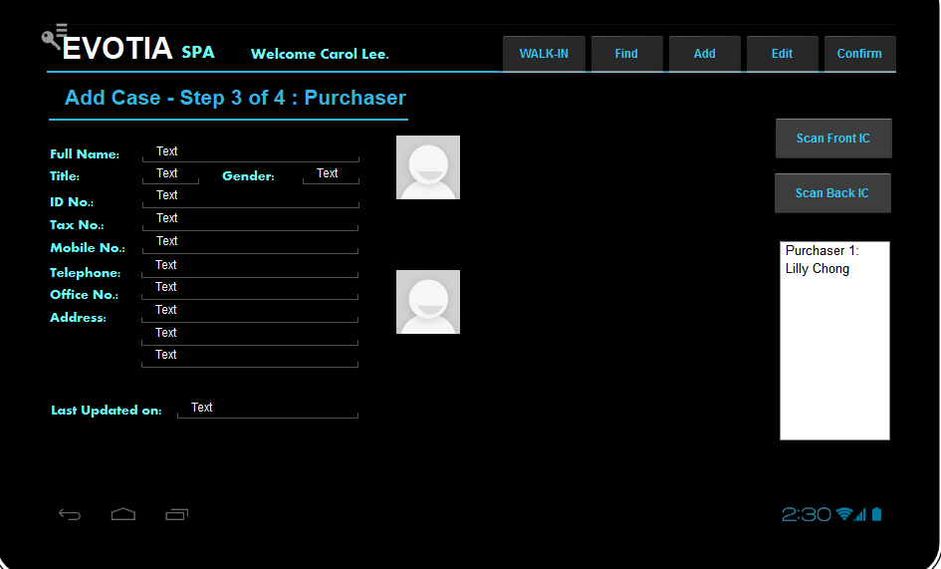

1. Add “Race” in list of fields.
2. User clicks Add to add a new Purchaser to the case via create a new Individual Record.
3. User clicks Scan Front IC and Scan Back IC to capture information to the new Record.
4. User click Confirm.
5. If user exists, follow steps from Page 7.  
   If user does not exist, create new individual record and link this record to new case file.
6. User clicks Find to add a new Purchaser to the case via referring to existing Individual Record.
7. List Box on the right will show the existing related parties added to the case up to now.
8. Fields will be replaced with Corporate data if Purchaser is a company.

# Add Case: Step 4

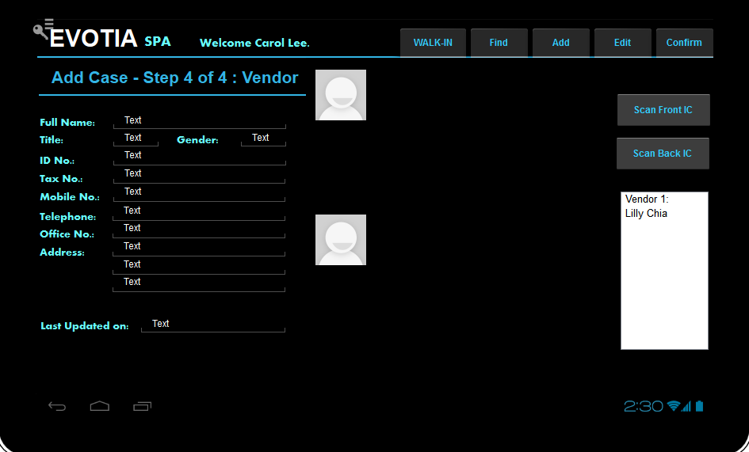

1. Same steps as Step 3. Type is Vendor.
2. Fields will be replaced with Corporate data if vendor is a company.

* Only CS & IC can create a new case.
* If IC is the one to create the case, the CS field in the case detail for the case is updated with the IC code.

# Case Enquiry – Details

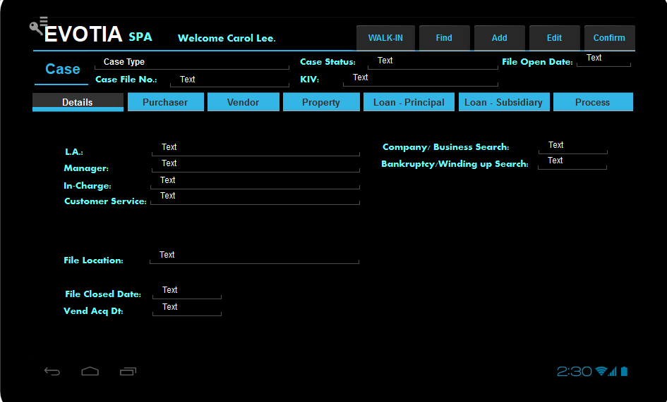

From this screen onwards:

1. Change ‘Status’ to ‘Case Status’ and ‘File Ref.’ to ‘Case File No
2. Change receptionist to “Customer Service”
3. Change Officer to “In-charge”
4. Change "Open Date" as "File Opened Date", "Closed Date" as "File Closed Date"

CR: Add “Case Type” before File Location in Detail’s tab.

Eg: Case Type : SPA - sub-sales

# Case Enquiry – Purchaser

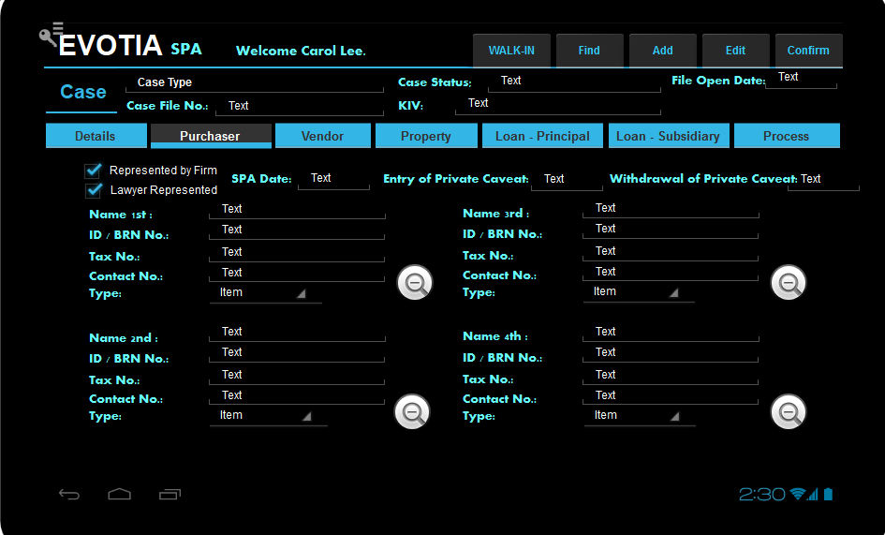

When "Represented by Firm" is checked for purchaser, under Vendor's tab "Represented by Firm" will be dimmed off.

When "Lawyer represented" is checked after "Represented by Firm" , the lawyer refers to Tia & Noordin.

CR: Discussed with Chris, we want add other Date(s) at top of each tab.

Remained the “KIV” and “File Opened Date”, move to the most right as follows,

|  |  |  |  |
| --- | --- | --- | --- |
| File Opened Date : | New date | New date | New date |
| KIV : | New date | New date | New date |

Insert New date into each tab as per following.

|  |  |  |  |  |  |
| --- | --- | --- | --- | --- | --- |
| **Details** | **Purchaser** | **Vendor** | **Property** | **Loan-Principle** | **Loan- Subsidiary** |
| Company/Business Search Date | SPA Date | Request for Developer Consent Date | Title Search Date | Letter of Offer Date | Loan Doc Forwarded to Bank for Exe Date |
| Bankruptcy/Winding up Search Date | Entry of Private Caveat (Purchaser): | Receive Developer Consent Date | Date Submit Consent to Transfer | Bank Instruction Date | Loan Doc Return from Bank |
|  | Withdrawal of Private Caveat (Purchaser) |  | Date Receive Consent to Transfer | Request for Redemption Statement | Facility Agreement Date |
|  |  |  | 14A Date | Date of Redemption Statement | Discharge of Charge (16N) |
|  |  |  | Date of Return of Title from Land Registry | Redemption Payment Date |  |

# Case Enquiry – Vendor

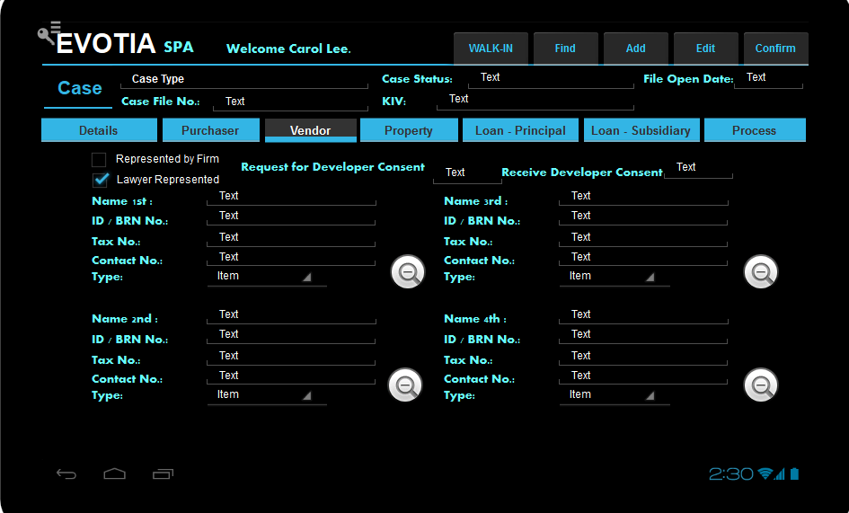

# Case Enquiry – Property

Allow user to swipe horizontally within the tab to go to next section.

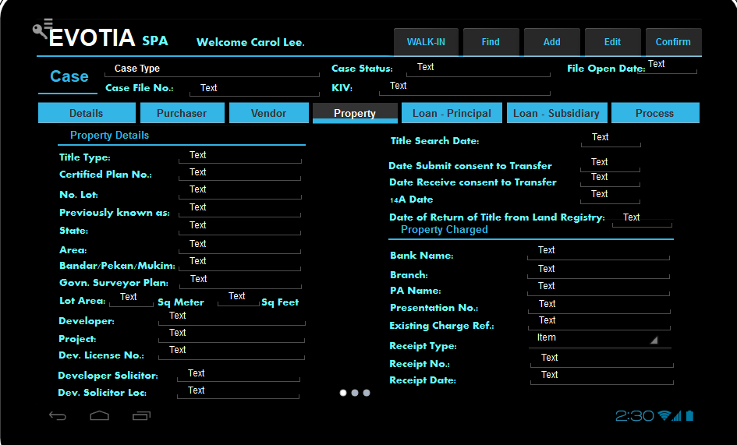

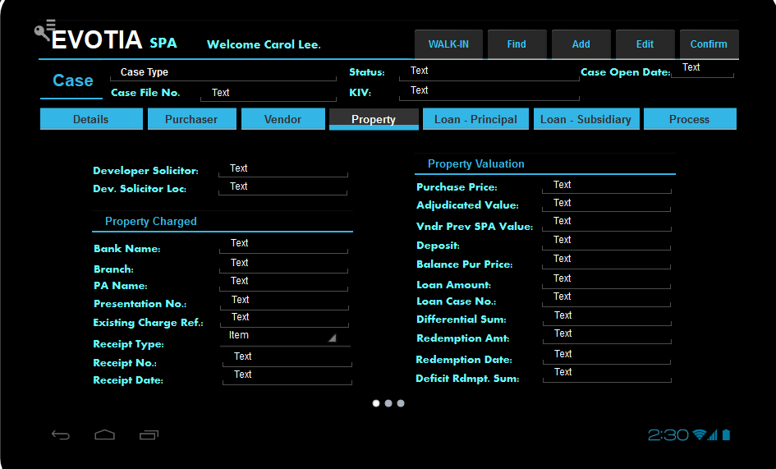

# Case Enquiry – Loan (Principle)

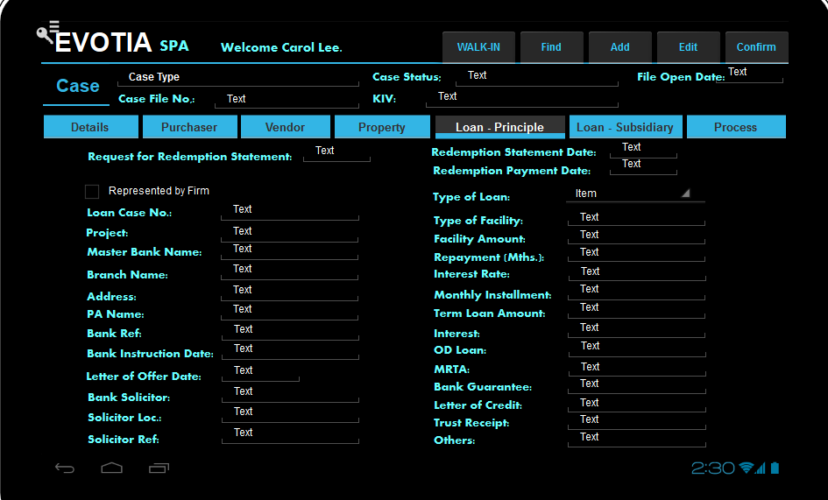

Case type - Loan will also use the same case enquiry as per Loan - Principle and Subsidiary tabs.

# Case Enquiry – Loan (Subsidiary)

Allow user to swipe horizontally within the tab to go to next section.

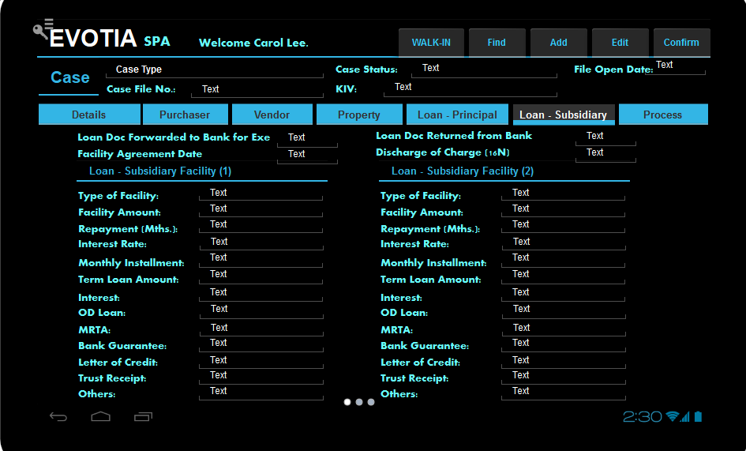

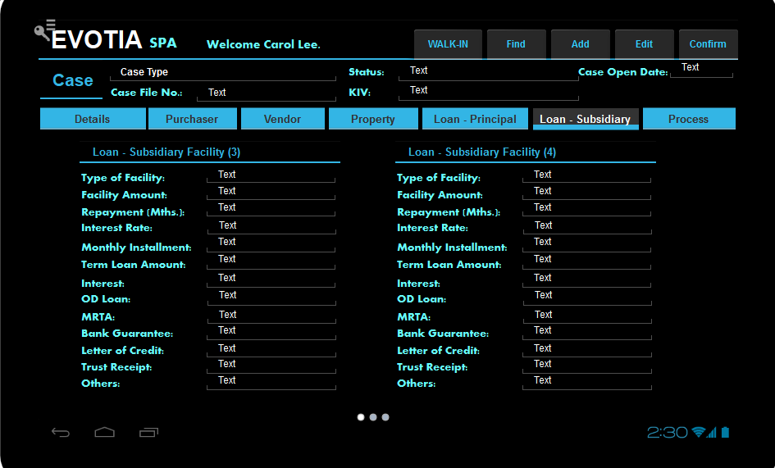

CR: Currently 5 Loan-subsidiary, can maintain 1 loan-subsidiary only. User will add (+) loan subsidiary if more than one then no need have 3 dots.

YH: Still need 3 dots if users use (+) 4 times. I need to check with team if can have both. If not will have to remain as 3 dots.

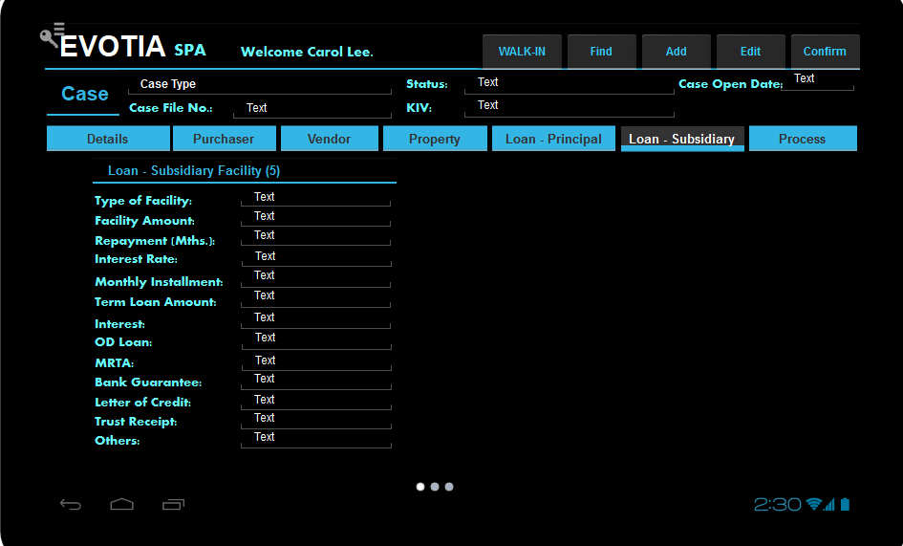

# Case Enquiry – Process

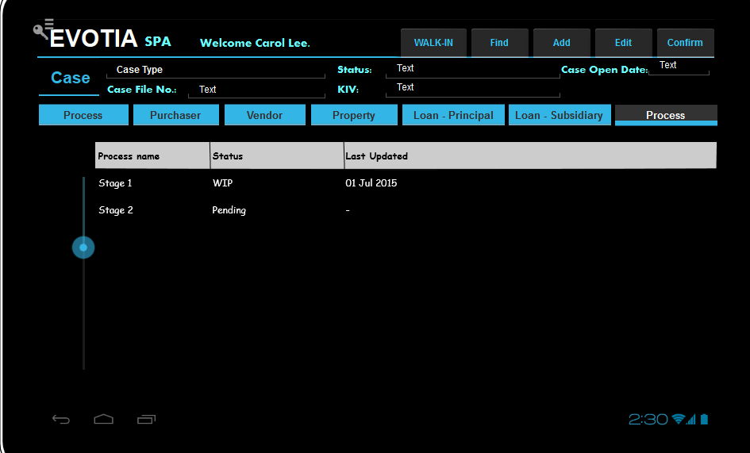

* The Sales Quotation BOM Parent Items will be shown in the table on the left.  
  Users will click to choose the Parent item to show in details in the left table.
* Users can click the zoom in button to show the scan documents if any.
* The table on the left will only show the processes that have completed (copied from sales quotation to Sales order and sales order is closed) or Work-in-progress (copied from sales quotation to Sales order and sales order is still open).

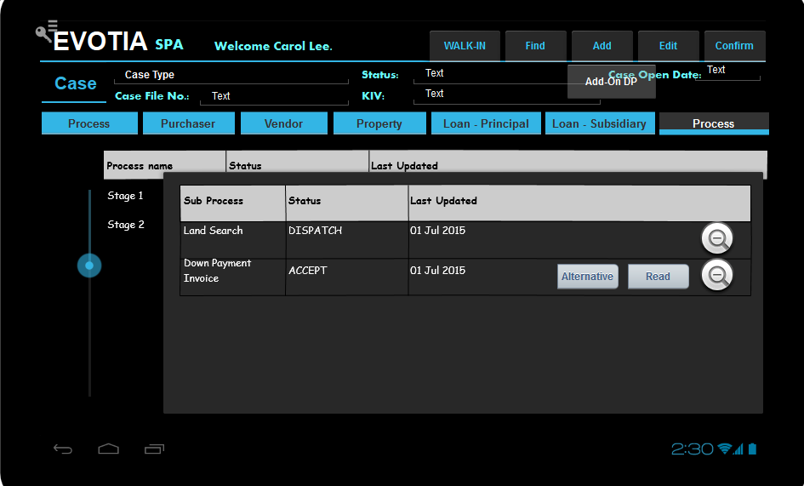

1. If the sales order is open, user can append additional items to the sales order.
2. If this additional item has alternatives, a “Alternative” button will appear for user to choose from alternatives.
3. Users can click the “Alternative” button to change the item to an alternative item.
4. User will click confirm to save the change and the “Alternative” button will disappear.
5. User can click “Read” button to read the scan file for the item.
6. User clicks the Add button. User click on one of the selection button such as “Add-on DP” to add an additional item to the subprocess.

CR: Ok

# Acknowledgement

By signing this page, **Tia & Noordin** acknowledges that this document accurately represents the requirement of **Tia & Noordin** for the Sales & Purchase Module of the Mobile Application, and that this document is the base for the system implementation. The actual delivered product may differ from the mock up in this document.

|  |  |  |
| --- | --- | --- |
| **Definition** | **Name** | **Signature and Date** |
| Project Sponsor | Chris Tia |  |
| Project Manger | Carol Lee |  |